Marker and whiteboard (or paper) games (2-player)

Sprouts rules
The game is played by two players, starting with a few spots drawn on a sheet of paper. Players take turns. Each turn consists of drawing a line between two spots (or from a spot to itself) and adding a new spot somewhere along the new line. In normal play, the player who makes the last move wins. In misère play, the player who makes the last move loses.
- A new line may be straight or curved, but cannot cross itself or any other line.
- No spot may have more than three lines attached to it.
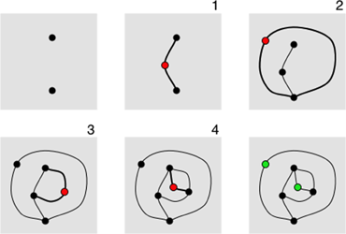

Dots and Boxes rules
Also called Capture. Played by two players on a grid of dots.
- Players take turns connecting two dots (horizontally or vertically).
- A box is marked with a player's letter (captured) if they close that box by completing the final side. You must draw another line after making a capture. A player may make multiple captures in a single turn.
- The player who captures the most squares wins.
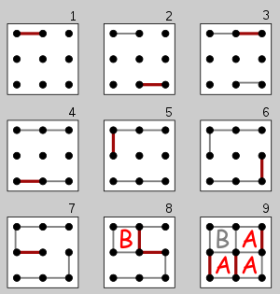

Connect6 rules
There are two players. X and O.
Connect6 is played on a square grid like tic-tac-toe. Grids smaller than 6×6 are automatic draws. 19×19 Go boards may be most convenient. For a longer and more challenging game, try 59×59.
X plays first, putting one X in one box. Then X and O take turns, each placing two stones in empty boxes each turn.
The first player to get six or more stones in a row (horizontally, vertically, or diagonally) wins.
The handicap of black only playing one stone the first turn makes the game fair; unlike games such as tic-tac-toe and Connect Four, which give the first player a large advantage.

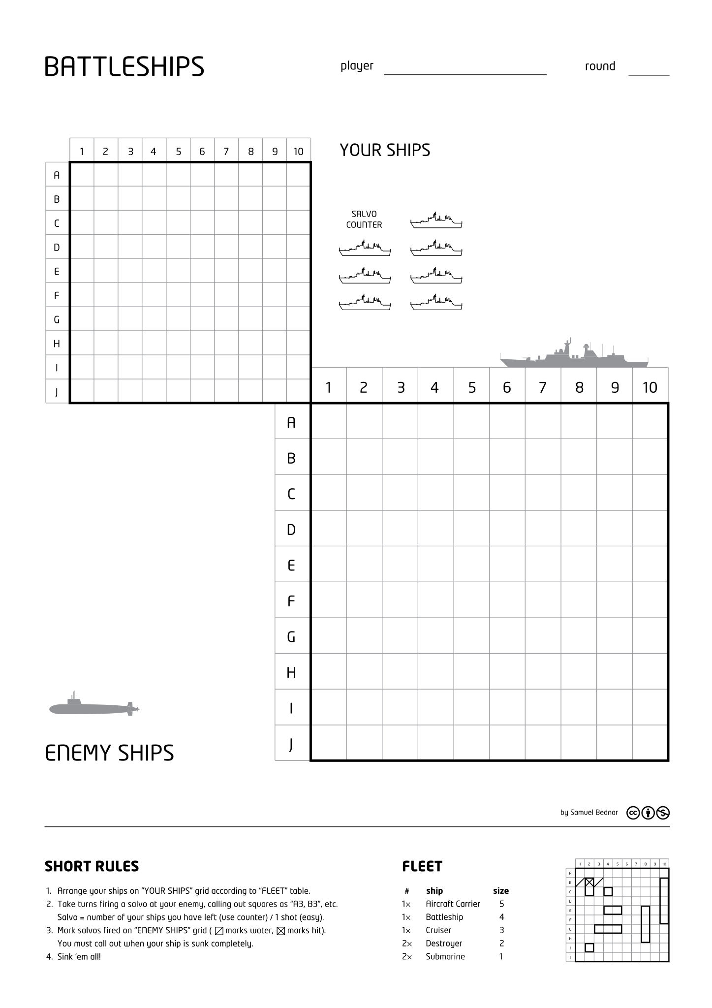
Games to play with markers
